

**PROTOCOL**for laboratory exercise

***Router introduction***

*(v2)*

|  |  |  |
| --- | --- | --- |
| Group / Class | Secretary | Signature |
| 5-6 / **3BHEL** | **HOFSTÄTTER A.** |  |
| Exercise- / Delivery date | Employee | Signature |
| 23th January 2013  30th January 2013 | **STRASSER A.** |  |
| Teacher | Employee | Signature |
| GRUBER |  |  |
| Grade | Employee | Signature |
|  |  |  |
| ***Network Address Translation***  ***Cisco 2901*** | | |
| **Used Devices**   |  |  |  |  |  | | --- | --- | --- | --- | --- | | Nr. | Device | Manufacturer | Type | Place Nr. | | 1. | **Router** | **Cisco** | **2901** | - | | 2. | **Switch** | **Cisco** | **Catalyst** | - |   **Used Programs**   |  |  |  | | --- | --- | --- | | Nr. | Name | Version | | 1. | **Terminal Emulation Software** | **-** | | 2. | **Putty** | **0.63** | | | |

ÜBUNGS-/ABGABE-DATUM

Klasse /Gruppe

NOTE

LEHRER

# Contents

1 Contents 2

2 Tasks 4

2.1 Network 4

2.1.1 Configured network and interfaces 4

2.1.1.1 LANs 4

2.1.1.2 Router to Router connections 4

2.1.2 **DCE** - IP Configurations 5

2.1.3 **DTE** - IP Configurations 5

3 Basic Router Configuration 6

3.1 Set Password and Secret 6

3.2 Change Hostname 6

3.3 Disable Domain Lookup 6

3.4 Synchronizing Log Messages 6

3.5 Enable Telnet Server for In-Band Configuration 6

3.6 Setup Web interface for Web Management 7

4 Configure Interfaces 8

4.1 GigabitEthernet0/0 8

4.2 GigabitEthernet0/1 8

4.3 Serial0/0/0 8

4.4 Serial0/0/1 8

4.5 Serial0/1/0 8

5 Setting up a DHCP Server 9

5.1 Configuration 9

6 Setup Internal Routing 9

6.1 Configure dynamic routes via RIP 9

7 Setup External Internet Routing 10

7.1 Configure Default-Gateway 10

7.2 Setup and configure NAT Overload (PAT) 10

8 Setup Port Forwarding 11

9 Testing and Debugging 12

9.1 Ping command Host/Router 12

9.1.1 Typical ping test output 12

9.2 Show commands 12

9.2.1 Show IP Route 12

9.2.2 Show Protocols 13

9.2.3 Show IP Protocols 13

10 Register of illustrations 14

# Tasks

In this laboratory exercise a star topology considering of 4 routers should be configured. The router to router connections were built with serial connections. Every of these 4 routers had its own LAN. In the converged network every LAN and every router should be reachable from every LAN or Router. Additionally the main router was configured with an Internet Uplink, NAT (especially NAT Overload or PAT) and port forwarding (on PCR1-1 a webserver was configured).

Note: The following steps describe how to configure Router R0. The other Routers (R1-R3) were configured by other groups. The main network node was R0. This router provides Network Address Translation and Internet Uplink for every routers and the Ethernets which were connected to these.

## Network

Figure 1. Network Topology

### Configured network and interfaces

As showed above the connections between the routers for the centralized star topology were built with serial connections. Behind every router some hosts in their own LAN are connected.

#### LANs

|  |  |  |  |
| --- | --- | --- | --- |
| R0 (Ethernet) | R1 (Ethernet) | R2 (Ethernet) | R3 (Ethernet) |
| 172.16.15.0 /24 | 172.16.224.0 /20 | 172.16.240.0 /20 | 172.16.208.0 /20 |

#### Router to Router connections

|  |  |  |
| --- | --- | --- |
| R0 – R1 (Serial) | R0 – R2 (Serial) | R0 – R3 (Serial) |
| 172.16.0.252 /30 | 172.16.0.248 /30 | 172.16.0.244 /30 |

Thereby a serial connection needs a DCE (Data Communication Equipment) and a DTE (Date Terminating Equipment) site the following configuration was selected. Every DCE serial interface got the first and DTE the second host address in the available network.

All DCE interfaces was chosen to be on R0. Therefore Router0 sets the clock rate for all serial connections.

|  |  |
| --- | --- |
| **DCE** - IP Configurations  * R0 – 172.16.0.**253** /24 * R0 – 172.16.0.**249** /24 * R0 – 172.16.0.**245** /24 | **DTE** - IP Configurations  * R1 – 172.16.0.**254** /24 * R2 – 172.16.0.**250** /24 * R3 – 172.16.0.**246** /24 |

The clock rate need to be set on the serial interface which is connected with the DCE site of the cable.

# Basic Router Configuration

One of the PCs was connected via a drilled console cable to the Router. Putty v0.63 was used to connect to the router via Serial Port. The baud rate was set to 9600 bauds.

## Set Password and Secret

To configure the router properly from a virtual terminal (e.g. telnet) an enable password/secret had to be set.

Router>enable

Router#configure terminal

Router(config)#enable secret cisco - Sets encrypted pass for privileged mode

## Change Hostname

The hostname in the lab network was changed from the default (**Router**) to **R0**.

Router(config)#hostname R0 - Change hostname

## Disable Domain Lookup

By default, when a command in user or enable mode is entered into a router and this command is not recognized, the router believes that this is the host name of a device that the user is attempting to reach using telnet. Therefore, the router tries to resolve the unrecognized command into an IP address by doing an IP domain lookup. If no specific domain server has been configured on the router, the router will issue a broadcast for the command to be translated into an IP address. It can take several seconds for the router prompt to return while the router waits for a response to its Domain Name System (DNS) broadcast.

R0(config)#no ip domain lookup - disables domain lookup

## Synchronizing Log Messages

This is very useful to synchronize system messages with the command prompt. By default the router displays a system message at every time no matter whether the user is typing or not.

R0(config)#line con 0 - Specify the line to be configured

R0(config-line)#logging synchronous- Enable synchronous logging of messages.

## Enable Telnet Server for In-Band Configuration

To configure the router via an In-Band method telnet was used.

R0(config)#line vty 0 1 - Specify the number of virtual terminals

R0(config-line)#password USER_PASSWORD- Set custom password for telnet.

R0(config-line)#logging synchronous- Enable synchronous logging of messages R0(config-line)#login

If the IP on the LAN interface (or the interface from which the telnet connection should be established) is configured and all packages are routed correctly. A telnet connection with the specified password and the interface IP address could be established.

From the time as telnet access was enabled the router was configured via two parallel sessions.

## Setup Web interface for Web Management

To setup a webserver for web access for managing the router from the webbrowser the built-in web server was enabled.

R0(config)#ip http server - Enables the Webserver on Port 80 (HTTP)

R0(config)ip http authentication enable - Specifies the enable password for login

From now on the Router is reachable on the interface IP address (172.16.15.1) on Port 80 with the enable password.

As username for the http login everything is correct. Thats because the router only checks the password and ignores every username.

Note: The hole setup was made via CLI. The webserver was only enabled for testing. Not for productive use and configuration.

# Configure Interfaces

## GigabitEthernet0/0

This Gigabit Ethernet port was used as the “WAN” interface for the router it was also used as the default routing way for packages which are determined for the Internet.

R0(config)#interface GigabitEthernet0/0 - Select specified interface

R0(config-if)#ip address dhcp - DHCP Client on this interface

R0(config-if)#ip nat outside - Specifies the interface as outside

R0(config-if)#no shutdown - Enables the interface

## GigabitEthernet0/1

This Gigabit Ethernet provides the local LAN (172.16.15.0 /24) at Router0 to connect multiple hosts via a switch.

R0(config)#interface Serial0/0/0 - Select specified interface

R0(config-if)#ip address 172.16.15.1 255.255.255.0 - Set IP Address and SNM

R0(config-if)#ip nat inside - Specifies the interface as inside

R0(config-if)#no shutdown - Enables the interface

## Serial0/0/0

This serial ports connects Router0 with Router1.

R0(config)#interface Serial0/0/0

R0(config-if)#ip address 172.16.0.253 255.255.255.252

R0(config-if)#ip nat inside

R0(config-if)#no shutdown

R0(config-if)#clock rate 8000000 - Sets DCE clock rate to 8M

## Serial0/0/1

This serial ports connects Router0 with Router2.

R0(config)#interface Serial0/0/1

R0(config-if)#ip address 172.16.0.249 255.255.255.252

R0(config-if)#ip nat inside

R0(config-if)#no shutdown

R0(config-if)#clock rate 8000000

## Serial0/1/0

This serial ports connects Router0 with Router3.

R0(config)#interface Serial0/1/0

R0(config-if)#ip address 172.16.0.245 255.255.255.252

R0(config-if)#ip nat inside

R0(config-if)#no shutdown

R0(config-if)#clock rate 8000000

# Setting up a DHCP Server

For the local LAN on Router0 a DHCP Server was established. This provides that IP addresses are allocated automatically and pushed to the Clients.

At first a DHCP Pool needs to be created. This pool contains the following very basic options.

* Network address and subnet mask
* Default Router (Gateway)
* Lease time (optional)

For a working name resolution some other options were added.

* DNS Server
* Domain Name

## Configuration

R0(config)#ip dhcp pool LABOR - Create specific DHCP pool

R0(dhcp-config)#network 172.16.15.0 255.255.255.0 - Specifies the network

R0(dhcp-config)#default-router 172.16.15.1 - Sets the Default-Gateway for clients

R0(dhcp-config)#dns-server 10.48.0.2 - Sets the DNS Server (on WAN site)

R0(dhcp-config)#domain-name labor.local - Specifies a domain name for hosts

R0(dhcp-config)#lease time infinite - Sets the lease time to infinite

R0(dhcp-config)# ip dhcp excluded-address 172.16.15.1 - Excludes the interface IP from pool

From now on every DHCP request which the router receives a DHCP request is created and pushed forward to the client.

# Setup Internal Routing

To route all local traffic properly two kinds of routing methods were used internally

* Static Route (Default Route for Internet provided traffic)
* Dynamic Routes with RIP

## Configure dynamic routes via RIP

In this network we use RIP as Routing protocol. It is easy to setup and use. Also good for small networks with less routers.

R1(config)#router rip - Configure RIP (v1)

R1(config-router)#network 172.16.15.0 - Add network (GigabitEthernet0/0)

R1(config-router)#network 172.16.0.252 - Serial0/0/0

R1(config-router)#network 172.16.0.248 - Serial0/0/1

R1(config-router)#network 172.16.0.252 - Serial0/1/0

By default RIP runs (sends and receive) on version 1. Therefore we used Subnets (especially VLSM and CIDR) the above shown RIP configuration could not work. That’s because RIPv1 uses the standard SNM for all network depending on their class.

This problems could easily be solved by switching to version 2.

R1(config-router)#version 2 - Change Version from v1 to v2

# Setup External Internet Routing

For correct routing of traffic which is determined for the global internet two things were configured.

## Configure Default-Gateway

If the destination IP address of an IP package on Layer 3 is not available in the routing table (see 9.2.1 Show IP Route) the package gets forwarded to the default gateway.

In this configuration the next hop router on the “WAN” site was chosen as the default-gateway. Usually this is the **P**oint **o**f **P**resence of the providing ISP (also called POP).

R1(config)#ip default-gateway 10.48.0.1 - Set default-gateway to ISPs POP

A basic static route command could also bring the same result.

R1(config)#*ip route 0.0.0.0 0.0.0.0 10.48.0.1* - Static Route (True for every package)

If no other routing entry for the destination address was found the packages gets forwarded to the default gateway (in most cases the ISPs POP).

## Setup and configure NAT Overload (PAT)

To translate all internal hosts to one and the same external IP address and difference ports NAT Overload was used. This provides secure separation and multiple users behind Router0 by connecting to the internet.

In chapter *4. Configure Interfaces* every interface got declared as *nat inside* or *nat outside*. This steps were very important for correct functionality for every type of NAT.

First a standard ACL with allowed Networks was created with the inside local address range and a standard wildcard (in this case the inverted subnet mask).

R1(config)# access-list 1 permit 172.16.0.0 0.0.255.255

Then NAT translation was configured with the before declared outside interface with the IP which was given to the GigabitEthernet0/0 interface (“WAN” Uplink).

R1(config)# ip nat inside source list 1 interface GigabitEthernet0/0 overload

From now the router translates every internal IP addresses from the network 172.16.0.0 /16, which bidirectional sends and receives traffic intendend for the outside internet, to the “WAN” interface the outside IP address assigned to the specified outside interface.

From now on the whole network (R0 – R1 and every LAN behind these routers) was able to reach the internet via R0.

# Setup Port Forwarding

To provide remote access from the “WAN” port (GigabitEthernet0/0) while NAT is activated port forwarding is required. With port forwarding the router creates a table which IP address gets IP packages delivered on a specific port from packages delivered on the “WAN” side of the router.

A webserver (Standard TCP Port 80) was running on the LAN behind Router1. It was reaching via the local network but not trough the “WAN” interface on Router0.

R1(config)#ip nat inside source static tcp 172.16.224.3 80 10.53.253.20 80 extendable

These configuration redirects all traffic from the “WAN” Port (IP 10.53.253.20) on TCP Port 80 to the local IP 172.16.224.3 (Host in the LAN behind R1) to port 80.

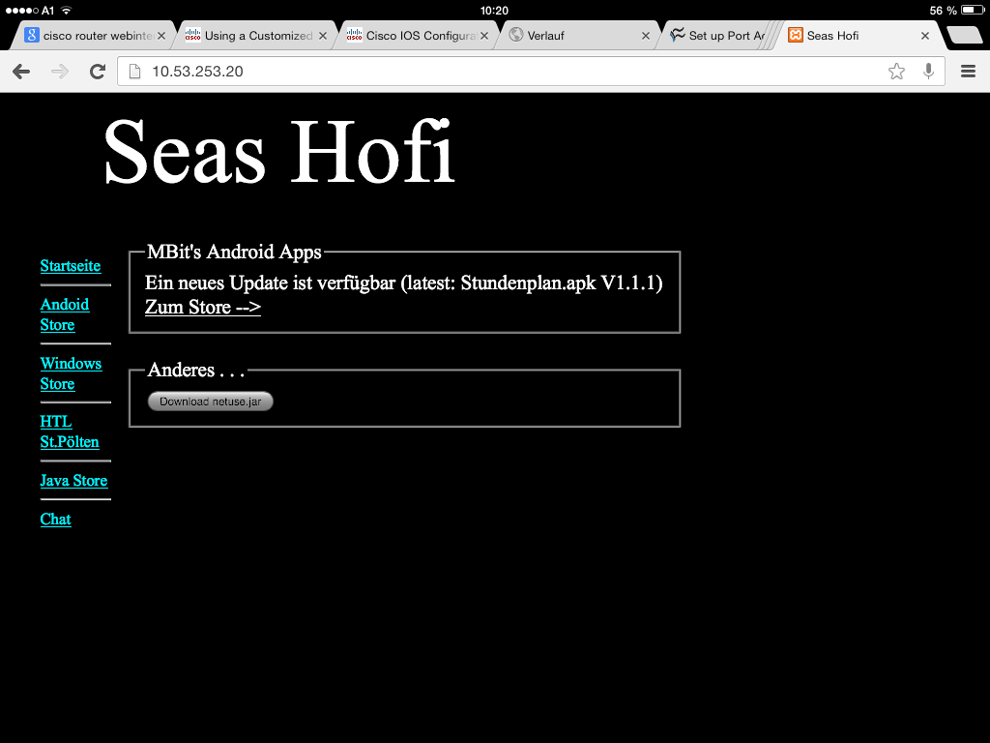

Figure 2. Webserver reachable via static port forwarding

The Client above (Tablet) was connected to the same network as the “WAN” interface of R0 was – GigabitEthernet0/0 (via a WLAN AP), but however still in the same logical network.

Therefore port forwarding was set up the connection to webserver which was running internally worked properly.

# Testing and Debugging

All Routers are now connected and configured with RIP and all RIP-Tables are up-to-date that means the network is converged.

## Ping command Host/Router

* Host1 (172.16.15.2) can ping every serial interfaces on Router R0-R3
* Host1 (172.16.15.2) can ping every LAN interfaces on Router R0-R3
* Host1 (172.16.15.2) can ping every host in other LANS behind R1-R3
* Host1 (172.16.15.2) can ping the internet (e.g. google.com, cisco.com)
* Host1 (172.16.15.2) can locally reach the webserver on 172.16.224.3

The same tests were made on other Hosts in other LANS and on other routers (R1-R3).

### Typical ping test output

This an output which is typically generated when 5 pings were 100% successfully.

R0#ping 172.16.240.3

Type escape sequence to abort.

Sending 5, 100-byte ICMP Echos to 172.16.240.3, timeout is 2 seconds:

!!!!!

Success rate is 100 percent (5/5), round-trip min/avg/max = 3/4/5 ms

## Show commands

The following show commands are all entered in the user EXEC mode.

### Show IP Route

R1#**show ip route**

Codes: I - IGRP derived, **R - RIP derived**, O - OSPF derived,

**C - connected**, **S - static**, E - EGP derived, B - BGP derived,

...

**Gateway of last resort is 10.48.0.1 to network 0.0.0.0**

**S* 0.0.0.0/0 [1/0] via 10.48.0.1**

**is directly connected, GigabitEthernet0/0**

10.0.0.0/8 is variably subnetted, 2 subnets, 2 masks

**C** 10.48.0.0/13 is directly connected, GigabitEthernet0/0

**L** 10.53.253.20/32 is directly connected, GigabitEthernet0/0

172.16.0.0/16 is variably subnetted, 8 subnets, 4 masks

**C** 172.16.0.244/30 is directly connected, Serial0/1/0

**C**  172.16.0.248/30 is directly connected, Serial0/0/1

**C** 172.16.0.252/30 is directly connected, Serial0/0/0

**C**  172.16.15.0/24 is directly connected, GigabitEthernet0/1

**R** 172.16.208.0/20 [120/1] via 172.16.0.246, 00:00:21, Serial0/1/0

**R** 172.16.224.0/20 [120/1] via 172.16.0.250, 00:00:05, Serial0/0/1

**R** 172.16.240.0/20 [120/1] via 172.16.0.254, 00:00:14, Serial0/0/0

In this table routes and by which IP or interface by which a net is reachable are displayed. This depends in RIP on two factors: Number of Hops (Metric) and Administrative Distance. If both factors are the same there are two routes available.

### Show Protocols

R2#**show protocols**

Global values:

Internet Protocol routing is enabled

GigabitEthernet0/0 is up, line protocol is up

Internet address is 10.53.253.20/32

GigabitEthernet0/1 is up, line protocol is up

Internet address is 172.16.15.0/24

Serial0/0/0 is up, line protocol is up

Internet address is 172.16.240.0/20

Serial0/0/1 is up, line protocol is up

Internet address is 172.16.224.0/20

Serial0/1/0 is up, line protocol is up

Internet address is 172.16.208.0/20

Above all interfaces with their actual status are shown. If they are up the configured IP Address and Subnet mask are shown.

### Show IP Protocols

R1#**show ip protocols**

Routing Protocol is "rip"

Sending updates every 30 seconds, next due in 20 seconds

Invalid after 180 seconds, hold down 180, flushed after 240

Outgoing update filter list for all interfaces is not set

Incoming update filter list for all interfaces is not set

Redistributing: rip

Default version control: send version 2, receive version 2

Interface Send Recv Key-chain

GigabitEthernet0/1 2 2

Serial0/0/0 2 2

Serial0/0/1 2 2

Serial0/1/0 2 2

Routing for Networks:

172.16.15.0

172.16.0.244

172.16.0.248

172.16.0.252

Routing Information Sources:

Gateway Distance Last Update

172.16.0.254 120 00:00:04

172.16.0.246 120 00:00:11

172.16.0.250 120 00:00:21

Distance: (default is 120)

This shows the actual information for the active routing protocols (RIPv2).

# Register of illustrations

Figure 1. Network Topology 3

Figure 2. Webserver reachable via static port forwarding 9